Ideation Phase
Brainstorm & Idea Prioritization Template

Date | 27 February 2026
Team ID | TSK841298
Project Name | HematoVision: Advanced Blood Cell Classification Using Transfer Learning
Maximum Marks | 4 Marks
Team Members | 1. Kuruva Siva | 2. Shaik Mohammed Junaid | 3. Bellary Sai Laxaman | 4. Abburam Veeresh

Brainstorm & Idea Prioritization Template:
HematoVision is an advanced deep learning project focused on automated blood cell classification using transfer learning techniques. The system accurately identifies and classifies blood cell types — Red Blood Cells (RBCs), White Blood Cells (WBCs), and Platelets — from microscopic blood smear images, targeting a classification accuracy above 95% to support hematologists in faster and more reliable clinical diagnostics.
This brainstorming and idea prioritization session was conducted by Team TSK841298 (Kuruva Siva, Shaik Mohammed Junaid, Bellary Sai Laxaman, and Abburam Veeresh) to identify, group, and prioritize the best techniques and strategies for building the HematoVision model — from data augmentation and backbone selection to model explainability and deployment.
Reference: https://www.mural.co/templates/brainstorm-and-idea-prioritization
Step-1: Team Gathering, Collaboration and Select the Problem Statement
A. Team Gathering:
The HematoVision project team (Team ID: TSK841298) was assembled with four members, each assigned a specific role to ensure comprehensive coverage of all project phases. The team members are: (1) Kuruva Siva — Team Lead and ML Architect, responsible for overall project direction and model architecture decisions; (2) Shaik Mohammed Junaid — Data Engineer, responsible for dataset collection, preprocessing, and augmentation pipelines; (3) Bellary Sai Laxaman — ML Engineer, responsible for model training, fine-tuning, and optimization; and (4) Abburam Veeresh — Model Evaluation Specialist, responsible for performance metrics, testing, and validation. All team members were briefed on the project scope and pre-work materials were shared prior to the session.
B. Set the Goal:
The primary goal of this session was to identify and prioritize the most effective deep learning strategies for automated blood cell classification. The team aimed to design a robust transfer learning pipeline capable of classifying Red Blood Cells (RBCs), White Blood Cells (WBCs), and Platelets from microscopic blood smear images with a target accuracy exceeding 95%, while ensuring the model is explainable and deployable in clinical environments.
Problem Statement (How Might We):
"How might we accurately classify blood cell types (RBCs, WBCs, and Platelets) from microscopic smear images using deep transfer learning techniques, so that hematologists can achieve faster and more reliable clinical diagnostics?"
C. Key Rules of Brainstorming followed:
All team members followed the six key rules during the session: (1) Stay in topic — all ideas focused on blood cell classification and transfer learning; (2) Defer judgment — no idea was dismissed during the ideation phase; (3) Go for volume — each member contributed a minimum of six ideas; (4) Be visual — ideas were illustrated with diagrams and model architecture sketches where possible; (5) Listen to others — all contributions were acknowledged before building upon them; (6) Encourage wild ideas — unconventional approaches such as self-distillation and semi-supervised learning were welcomed.
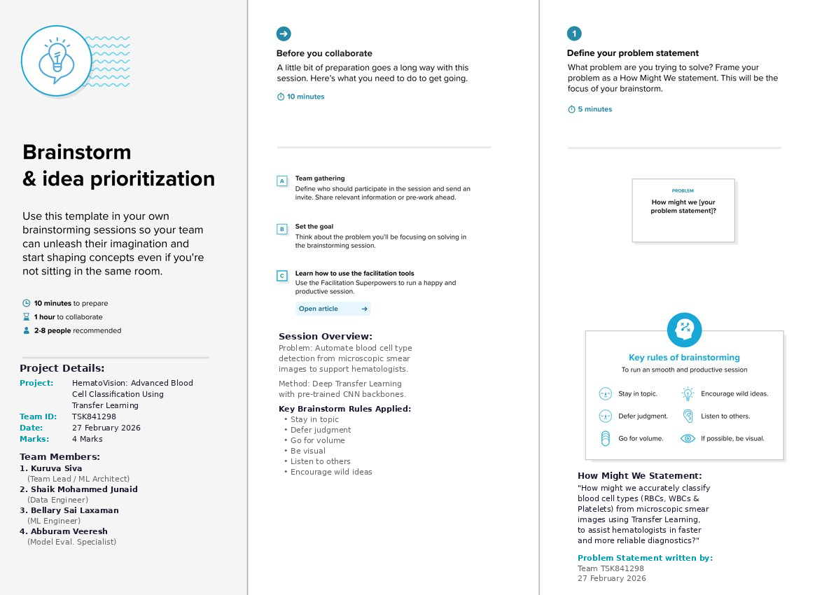

Step-2: Brainstorm, Idea Listing and Grouping
Individual Brainstorm (10 minutes):
Each team member independently generated ideas addressing the HematoVision problem statement. Kuruva Siva proposed model architecture strategies including VGG16 transfer learning, ResNet50 fine-tuning, attention map visualization, hyperparameter tuning, model ensembling, and Grad-CAM explainability. Shaik Mohammed Junaid contributed data strategy ideas: SMOTE class balancing, data augmentation (flipping, rotation, zoom), multi-scale input patches, pseudo label generation, semi-supervised learning, and train-test split optimization. Bellary Sai Laxaman suggested backbone alternatives: EfficientNet-B4, InceptionV3, MobileNetV2 for edge deployment, curriculum learning, patch-based classification, and domain adaptation techniques. Abburam Veeresh proposed evaluation and deployment ideas: F1-score per class, confusion matrix analysis, ONNX model export, edge device deployment, low-latency inference optimization, and self-distillation methods.
Idea Grouping into Clusters (20 minutes):
After individual brainstorming, the team took turns sharing ideas while clustering similar or related notes. Four major clusters were identified and labeled:
Cluster 1 — Model Architecture: VGG16 transfer learning, ResNet50 fine-tuning, EfficientNet-B4 backbone, InceptionV3 model, MobileNetV2 edge model, and ensemble of CNNs.
Cluster 2 — Data Strategy: Data augmentation, SMOTE class balancing, multi-scale input patches, pseudo label generation, semi-supervised learning, and curriculum learning strategy.
Cluster 3 — Explainability and Evaluation: Grad-CAM XAI visualization, attention maps, F1-score per class, confusion matrix evaluation, and domain adaptation techniques.
Cluster 4 — Deployment and Inference: ONNX model deployment, edge device deployment, low-latency inference optimization, self-distillation method, and patch-based classification.
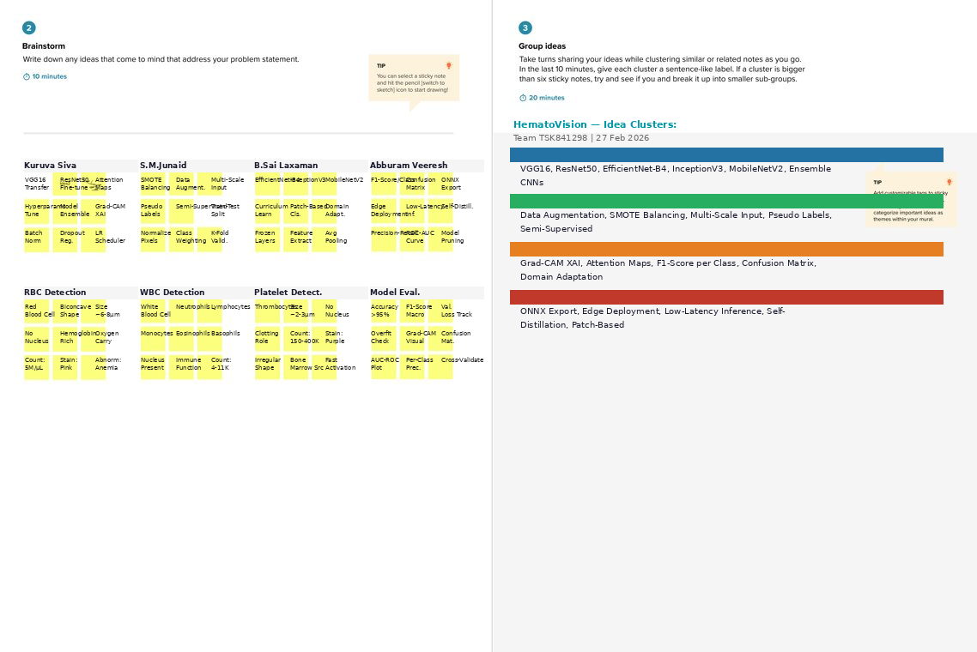

Step-3: Idea Prioritization
The team placed all 24 brainstormed ideas on an Importance vs. Feasibility priority matrix (20 minutes) to determine which ideas to pursue first, plan carefully, use as quick wins, or deprioritize. The matrix was divided into four quadrants based on two axes: Importance (positive impact on classification accuracy and clinical utility) and Feasibility (cost, time, effort, and implementation complexity).
DO FIRST — High Importance, High Feasibility (Top Priority):
ResNet50 fine-tuning, EfficientNet-B4 backbone, Data Augmentation, Grad-CAM XAI visualization, SMOTE class balancing, and InceptionV3 backbone. These ideas were identified as having the highest positive impact on model performance and are readily implementable within the project timeline using available frameworks (PyTorch, TensorFlow, Keras).
PLAN CAREFULLY — High Importance, Low Feasibility:
Ensemble of CNNs and Semi-supervised learning. These approaches can significantly boost accuracy but require additional computational resources, careful tuning, and more development time. They will be planned for a later project phase after the baseline model is established.
QUICK WINS — Low Importance, High Feasibility:
ONNX model deployment, VGG16 transfer learning, and MobileNetV2 edge model. These are easy to implement and provide deployment-readiness or quick baseline results, even though they do not directly maximize classification accuracy. They can be completed alongside the primary model development.
DEPRIORITIZE — Low Importance, Low Feasibility:
Self-distillation method, Curriculum learning strategy, and Pseudo label generation. These are experimental techniques that require significant R&D effort with uncertain benefit within the current project scope and timeline. The team agreed to revisit these only if time permits after the primary objectives are achieved.
Final Team Decision and Next Steps:
Following the prioritization session, the team reached consensus on a phased execution plan: Phase 1 — implement ResNet50 and EfficientNet-B4 as primary transfer learning models with data augmentation and SMOTE balancing; Phase 2 — integrate Grad-CAM for model explainability and F1-score per class for evaluation; Phase 3 — export the final model via ONNX for deployment. The brainstorm and idea prioritization session was exported and shared with all stakeholders as part of the HematoVision project documentation (Team ID: TSK841298, Date: 27 February 2026).
